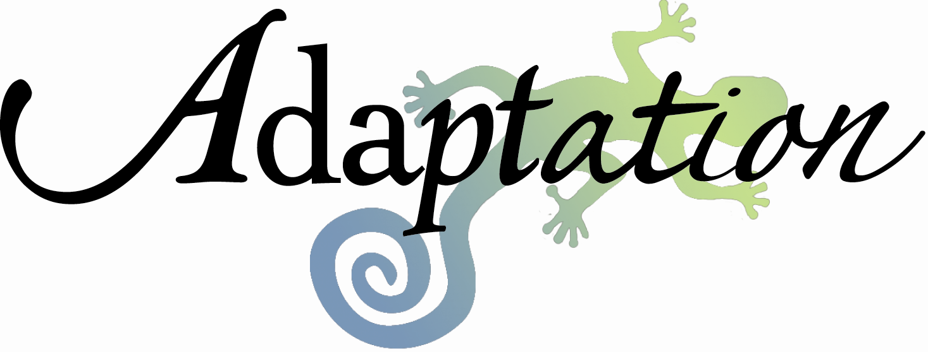
: Office Policies
Evan Marks, LCSW-C • 4405 East West Hwy, Bethesda, MD 20814 • 240-547-7497 • www.adaptationlife.com

Adaptation is an individual private practice. Although the practice is located in an office suite I have no official affiliation to the other providers in the suite. Adaptation’s standard hourly fee is $175 per 50 minute therapy session and $175 per hour for other professional services that you may need. Services outside of therapy will be prorated to account for work that takes less than one hour. Other services might include report writing, telephone conversations lasting more than 15 minutes, attendance at meetings with other professionals that you have authorized, preparation of records or treatment summaries, and time spent performing any other services you may require.

I am generally available after 9:00 am and until 8:00 PM by phone Monday through Friday. I am available on the weekends by phone in emergency only. I do not answer emails over the weekend. I will make every attempt to return your phone calls within 24 hours or sooner depending on the nature of the phone call. Please be aware that because I am often in session I may not get your message immediately. If you are undergoing a psychiatric emergency and feel like you are a threat to yourself of to someone else I ask that you call 911 immediately and request help.

Adaptation asks that payment for services be made at the time of service. Payment may be made using cash, check, or credit. In addition, an online option for credit is available for patients who prefer to pay online after the session. If you are truly unable to afford counseling services please ask about Adaptation’s limited reduced fee program.

It is your responsibility to work with your insurance company regarding reimbursement. When your insurance carrier requests information regarding a treatment plan or anything else to facilitate coverage, I will make every attempt to provide the necessary information. If you intend to seek reimbursement though your insurance company please notify me at the beginning of treatment.

A notification of 48 hours is required for cancellation of a session. This allows your session time to be made available to other people who are seeking services. You will be charged $75 for any sessions canceled with less than 48 hours notice. There will be no charge for sessions missed because of heavy snow or serious traffic tie-ups.

Although therapy is very effective for many people, be aware that in some cases symptoms may get worse before they get better and there is no grantee that the symptoms you are seeking treatment for will improve and depending on the nature of your symptoms your symptoms may actually worsen. Also be aware that it is normal to hit road blocks in treatment or occasionally get upset by something your therapist says. Many patients find that working through these difficult moments are key moments of change. For this reason, I encourage you not to terminate without meeting one last time in person to discuss the matter.

In cases of litigation, Adaptation may release your treatment records at your request but cannot actively endorse you in these matters as it could create a conflict of interest. In agreeing to these office policies you are agreeing not to request testimony or endorsement regarding matters related to child custody or social security disability.

Adaptation reserves the right to modify any of its office policies. In the case of a modification you will be given at least 30 days notice before the changes take effect.

